SMART Survey Aggregator
  - A tool for merging individual SMART datasets
Standardised Monitoring and Assessment of Relief and Transitions or SMART is a sampling method to collect data quickly, often during an emergency, on the anthropometric status of children and on recent deaths in households. The method takes a random sample of 15 to 30 children and their households in a random sample of 20 to 30 villages in an area, so is a cluster sample. The number of clusters and children required is estimated using ENA software which applies estimates of the prevalence of the key indicator required, usually the percentage of wasted children, the precision of the estimate required, and an estimate of the degree of clustering applied as a design effect. The SMART sampling method is being applied more widely as a part of nutrition surveillance, which is defined as the regular and systematic collection of data on nutritional indicators.
A basic SMART survey consists of data on the sex, age and anthropometric measurements of all children aged 6 – 59 months in a household and data on deaths in same household during a specific recall period. As the names of basic variables are standardised by ENA software, the programme can also append one anthropometry dataset to another.
A single dataset would enable a greater depth of analysis of each SMART survey and then, if the variables in each single SMART dataset were harmonised in name, format, coding and labels, they could be appended to each other to create a dataset of multiple surveys and then analysed over time and space. There would also be the possibility to add data from other sources to increase the potential for analysis.

Terminology
The terms used in this document need to be defined clearly so that there will be no confusion about what is described.
Survey. A survey is the method by which data is collected in a process of sampling and measuring subjects; their data are recorded (on paper or electronically), processed, checked for quality and analysed; and then the methods, results and findings are described and reported.
SMART survey. This is a survey done using the sampling methods recommended by SMART, the Standardised Monitoring and Assessment of Relief and Transitions. The aim is usually to assess the anthropometric status of children aged 6 to 59 months and recent mortality in the child’s household. The data collected to assess anthropometric status include the age, sex, weight, height and mid upper arm circumference of children from which the ENA software calculates the z-scores of weight-for-height, weight-for-age and height-for-age using WHO reference standards.
Survey collection. A survey collection consists of a set of electronic files consisting of, or containing: the SMART survey questionnaire, the dataset, the data quality analysis, and the narrative report of the analysis of data. The narrative report may contain the questionnaire and the data quality analysis as well as a description of the survey and the results of the analysis. The text files may be stored as a Microsoft Word document (.doc), as an Adobe portable document file (.pdf) or in another text format. These original files will be stored in a survey collection repository.
Surveys repository. This is a store of the survey collection from all SMART surveys. It includes the original SMART survey dataset. Files can be accessed through the search interface.
Dataset. A dataset is a table of data in which each row represents a record and each column represents a variable. A SMART survey usually has two datasets associated with it, an anthropometry dataset and a mortality dataset, but may have more than two. For example, there may be additional datasets with information about the mother of the child or data on the child’s household. This aggregator considers only anthropometric data on children, so when we refer to a survey dataset, this will contain the anthropometry data on the child. The dataset is a unique file stored in the native SMART format (.as) or may have been converted to an Excel file (.xls or .xlsx).
Database. This refers to a collection of data, organised as a dataset and searchable. All fields comprising the data in a database are described and defined in the master data dictionary, described further.
Record. A record is a set of fields containing data on a specific subject. In a SMART survey a record is a row in a dataset containing all the data recorded on a specific child in set of fields, one for each variable. The same is true for a record of a database.
Variable. This refers to the information that characterises the values of a specific kind. It includes what the value or measurement refers to and the format in which values are recorded. For instance, a variable containing data on the height of a child will have a name that uniquely identifies the variable among all others; it will have a label that describes what the data refers to and will record the unit in which the value is expressed if it is numeric and other information that can be used to disambiguate the variable or validate the variable’s value. In a dataset, a single column contains values belonging to a single variable. The data in the variable will be stored in a defined format depending on the type of data which could be a number (numeric or integer), letters or numbers (alphanumeric), or a date (years, months, days).
Field. A field is a value of a specific variable for a specific record. Each cell or row/column combination in a data table, is a field containing a value.
Data. This is the content of the fields of a dataset. It may contain numbers, letters or both.
Data dictionary. This is a catalogue of the name, label and format of each variable in a dataset, or database. SMART survey datasets in their native format usually only contain the variable name, but no label. The format of the data is predefined in ENA software.
Master data dictionary. This is a catalogue that gives a standard name, label and format to each variable found in a SMART child anthropometry dataset in a process of harmonisation so that a single variable name, label and format is applied to the same data in every dataset, allowing them to be merged. This will allow datasets with non-standard variable names or variables named in different languages to be appended to each other to create a dataset of survey datasets. New variables may be added to the master data dictionary, if necessary. The definitions in the master data dictionary also apply to data in the application databases.
Harmonising. This is the process of matching each variable in each SMART dataset with the standard variable listed and described in the master data dictionary. The goal is to have all datasets share the same variable name, label and data format for a set of standard common variables. This means that each variable in the SMART datasets that correspond to a variable in the master data dictionary will be named and formatted in the same way, so that, for instance, the survey date in one dataset will be named in the same way in all other datasets that feature this variable. Data recorded as letters such as sex (m or f) and how a child was measured (h for height or l for length) will be converted to numeric codes when exported. This means that all datasets featuring a set of standard variables will have the same variable name and label, allowing many datasets to be appended to each other in a single searchable database.
Database of surveys. This is a database in which each record contains descriptors and metadata about a single SMART survey, as well as links to the surveys collection of files associated with that survey. Each SMART survey that is added to the database of datasets will be included as a record. This database can be searched to identify specific surveys that match specified characteristics and the records can be exported as a new file for analysis.
Database of datasets. This is a single table containing all SMART surveys after the variables have been harmonised. It can be searched to select records that match specific criteria which can then be exported as a new file for analysis.
Metadata. Metadata is data, or information about other data. The information comprising a variable, that is, its name, label, definition, data type, format etc. are considered metadata. Information about a SMART survey such as the identifier, title, sample size and start date of a survey are also considered to be metadata. The contents of a dataset, however, are considered here data. Metadata is expressed in the same way as data, as a table in which the row represents a variable or a survey and each column represents the metadata variable, such as identifier, label or start date.

Software concept
A SMART survey repository can be implemented as a software application, in which each user can add survey datasets, questionnaires and reports to a local searchable repository and then select datasets and export their data as a single table in a format that can be imported into data analysis software where variables can be labelled. The datasets in the local repository can also be added to a central repository. The repository requires that each dataset is uniquely identified and that variables in the datasets are harmonised with the variables in the master data dictionary so that all variables are matched, named, formatted and labelled in the same way.
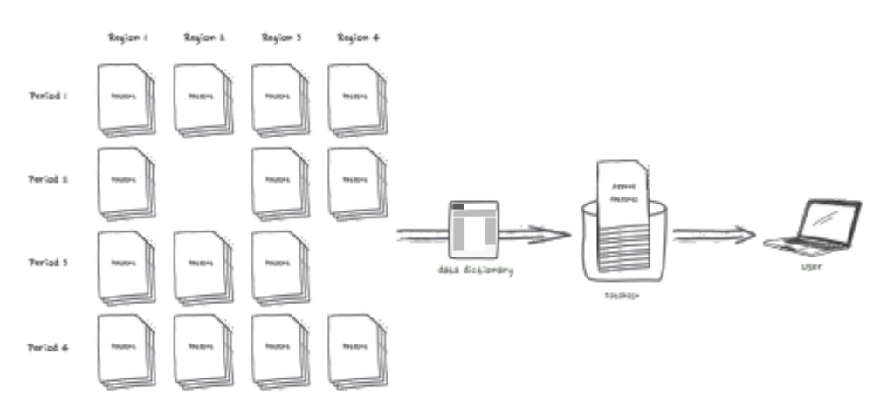
The benefit of this software application is to provide both a local and a central repository for all SMART survey datasets in which it will be easy to find and select individual surveys or create new datasets for analysis with data from several surveys or selected records. Some of the operations that could be performed are:
- Select all datasets from a specific region, including sub-regions
- Select all datasets collected during a specific period.
- Select all datasets that contain data from a set of common variables.
- Select all surveys and/or data following a query criteria on common dataset variables or survey metadata.
- Select all records that meet specific criteria
- Export these selections in several file formats.
- Export a compressed archive file containing a selection of surveys.
This software application could be deployed as a web site portal to search the database of surveys and database of datasets, allowing easy access from any location and requiring only a web browser as its user interface.

Software functionality
There are six main functions that the application should fill.
- Upload the survey collection for each SMART survey to the surveys repository and register the files.
- Create a record for the survey in the database of surveys and add metadata about the survey plus the name and location of the associated files.
- Add SMART datasets to the database of datasets. This involves the following:
  - Give the new dataset a unique identification code based on fixed criteria (location and date) and check that this code is not already in the database.
  - Open the dataset and harmonise the variables with the variables in the master data dictionary.
  - Add additional information to each record in the dataset on the location, year, month, sample size and number of clusters in the survey extracted from the survey report and add indicators of data quality extracted from the data quality report.
  - Save the new dataset and undertake consistency checks.
  - Append the dataset to the database of datasets and save it.
- Allow users to search the database of surveys for records that meet specific criteria and combine this with a search of records in the database of datasets that meet specific criteria. The results will be shown in two screens: one showing the surveys that contain records that meet the criteria, and one showing the records in the database of datasets that meet the criteria.
- Allow users to download the files associated with the datasets selected from the survey collections repository.
- Allow users to export the records that meet specific criteria as a comma separated variable (.csv) file. The file can then be loaded into statistics software such as Stata and processed by a standard do file to add variable labels and value labels. Syntax files could also be written to label the variables in SPSS and other statistical software.
These components will not be available to all users, so a system to manage what users can do will be required.

Software components
All data will be managed in a database that contains four main elements: the surveys collection repository, the database of surveys, the database of datasets and the master data dictionary.

1. Surveys collection repository
The surveys collection repository will contain all the files related to each survey: the questionnaire, the original dataset, the data quality report (also called a plausibility check) and the narrative report of the survey. The narrative report may contain the questionnaire and the data quality report. Any other files will also be registered.

2. Database of surveys
This will be a searchable database in which each record contains data on a SMART survey which has been included in the database of datasets. Table 1 shows a list of variables that it will contain.
Table 1. A list of the variables that describe a survey.
Variable name | Type | Description
IDENTIFIER | Alphanumeric | An alphanumeric code that uniquely identifies the survey in the repository.
LOCATIONS | List of codes | Breakdown of locations covered in the survey. This could be in the form of a list of location codes that can be used to query all surveys that were conducted in specific locations
STARTDAT | Date | Start date of survey
ENDDAT | Date | End date of survey
SURVYEAR | Year | Year in which the survey was done.
SURVMON | Month | Main month in which the survey was done.
AGENCY | Name or numeric code | Main agency collecting data.
ORIGNAME | Alphanumeric | Original survey file name, or code number of survey report.
SAMPMETH | Enumeration | Method of sampling, a code e.g. cluster, random.
SAMPSIZE | Integer | Number of subjects in the study.
Besides the above fields, the record of the survey will feature the individual values and scores of the data quality report generated by the ENA software. Each element of variables in Table 2 will be divided into two subfields: VALUE, which will contain the raw value and SCORE, that will contain the SMART score. The overall score will also be given.

Table 2. Data quality criteria to be included in the dataset of surveys.
Variable name | Description
PCFLAGS | Percentage of records with subjects out of range.
PCSEXRAT | P value of Chi squared for sex ratio.
PCAGERAT | P value of Chi squared of age ratio.
PCDPWT | Digit preference score for weight.
PCDPHT | Digit preference score for height.
PCDPMUAC | Digit preference score for MUAC.
PCSTDEV | Standard deviation of WHZ.
PCSKEW | Value of skewness WHZ.
PCKURT | Value of kurtosis WHZ.
PCPOISS | P value that index of dispersion is not a Poisson distribution WHZ-2.
PCSCORE | Overall data quality score (contains only the score).
The database of surveys will also contain other data and links to the files related to each survey stored in the surveys collection repository, this information is internal and will not be included in user searches. This information is shown in Table 3.
Table 3. Other data to be recorded in the dataset of surveys.
Variable name | Type | Description
DATASET | List of structures | A list of links to the survey dataset files, this will be used to download the original datasets. Each element of this list could be composed of four subfields:  - IDENTIFIER: This subfield would contain the unique identifier of the dataset, it will be used to download the original dataset and to link records in the database of surveys to the dataset they belong to.  - TYPE: This subfield should indicate the type of dataset: child, mother, household or mortality. This value can be used to limit searches to a specific type of datasets.  - STATUS: This subfield should reflect the status of the dataset; this field can take the following values:  - Public. This value indicates that the dataset will be included in all searches.  - Restricted. This value indicates that only certain users will have access to the dataset.  - In progress. This indicates that the dataset is being harmonised or edited, it will not be included in searches.  - USER: This subfield should contain the identifier of the user responsible for the dataset. It could either be the user that uploaded it, or a user that is the curator of the dataset.
QUESTLINK | Link | A link to the questionnaire file, this will be used to download the survey questionnaire, if it is not included in the report.
REPORTLINK | Link | A link to the report file, this will be used to download the survey report
The above two tables represent a tentative list of variables that describe a survey. In addition, it could be enriched by a subset of fields, for instance from the DDI standard or the Darwin Core standard, which cover the goals, methods and sources of the surveys. This list of variables will be stored and documented in the master data dictionary and will constitute the attributes that can be used when searching for surveys.

4. The database of datasets
This will be the main repository of SMART datasets: a single dataset consisting of individual SMART surveys for which the variable names have been harmonised and descriptive variables have been added. It will contain the variables listed in the master data dictionary.
Both the database of surveys and the database of datasets will contain variables which will either be the raw data collected during SMART surveys or metadata, which provides information about each variable. Each of these variables will have attributes, the types of which are listed in Table 4, and which will be used to harmonise the variables.
Table 4. The standard variables in a SMART dataset of child anthropometry.
Variable name | Type | Coding | Units | Label
SURVDATE | Date |  | YYYY-MM-DD | Date subject studied.
CLUSTER | Integer |  |  | Cluster identification number.
TEAM | Integer |  |  | Team identification number.
ID | Integer |  |  | Subject identification number.
HH | Integer |  |  | Household identification number.
SEX | Letter | m = male; f = female |  | Subject sex.
BIRTHDAT | Date |  | YYYY-MM-DD | Subject birth date.
AGE | Number |  |  | Subject age in months.
WEIGHT | Number |  | kg | Subject weight.
HEIGHT | Number |  | cm | Subject height.
OEDEMA | Number | 0=none; 1=mild; 2=moderate; 3=severe |  | Œdema classification.
MUAC | Number |  | mm or cm | Left mid upper arm circumference.
WAZ | Number |  |  | Z-score of weight-for-age.
HAZ | Number |  |  | Z-score of height-for-age
WHZ | Number |  |  | Z-score of weight-for-height
MEASURE | Letter | l = length; h = height
CLOTHES | Letter | y = yes; n = no
STRATA | Integer
WTFACTOR | Number
Each record in the database of datasets will need to have additional variables to identify the location associated with each record, a link to the dataset from which the record comes from and the type of the dataset from which the record was taken. These variables are listed in Table 5.

Table 5. Additional information to be added to the database of datasets.
Variable name | Type | Description
LOCATION | Enumeration | Each data record should indicate the location of the survey. This information might be already present in the dataset, if that is not the case, it should be added automatically to each dataset record by the software when providing the survey information. This variable should ideally be a single hierarchical controlled vocabulary starting from the nation, down to the lowest national subdivision covered in the surveys.
DATASET | Link | Each data record should reference the dataset and survey to which it belongs, this variable would contain the identifier of the dataset file, as described above in the DATASET.IDENTIFIER variable in the surveys collection.
TYPE | Enumeration | This variable would contain the second sub-field of the related surveys collection DATASET.TYPE variable, it will indicate the type of the dataset (child, mother, household or mortality).

3. The master data dictionary
In order to merge SMART datasets into a single dataset, the names and format of each variable need to be harmonised. This will be done by naming and formatting variables according to the name and format stored in a master data dictionary. Merging data from all surveys into a single dataset will allow users to query all the records contained in the repository.
The master data dictionary will be managed by a super-user and will be supplied to all users who are intending to add SMART surveys to a repository.
The application’s master data dictionary will come pre-filled with the 15 standard SMART variables created by the ENA software, with their name, type, format and label shown in Table 6.
Table 6. The attributes that will be applied to variables in the database of surveys and the database of datasets depending on the type and function of the variable.
Variable | Type | Description
NAME | String | The variable name or identifier is an alphanumeric code that uniquely identifies the variable in the data dictionary. For instance, “SURVDATE”, as listed above, is the name of the field containing the survey date. This name will be placed in the header row of exported data selections and should be unique among all variable names.
LABEL | Multi-language string | This represents a short description of the variable, it should provide enough information to determine what the variable represents. This is equivalent to the label of a field in a form.
DEFINITION | Multi-language string | This should contain the full and exhaustive description of the variable, the data it hosts and the method used to obtain it. All the necessary information should be included so that there can be no doubts on what data the field contains. This information becomes essential when we add new variables beyond the ENA standards to the data dictionary.
KIND | Enumeration | Since both survey metadata and dataset variables will be stored in the data dictionary, it is necessary to distinguish which variables refer to data in the datasets and which variables refer to metadata not related to the dataset contents, this information will be used to select which variables will be available in the harmonisation process.

Table 6, continued
Variable | Type | Description
TYPE | Enumeration | This entry indicates the type of the data recorded in a variable, it is a controlled vocabulary that classifies the format in which the data will be stored and expected. This type covers specifically the storage format and can take the following values:  - date: a value that indicates a date with day, month and year. Dates will be converted to the YYYY-MM-DD format when the data will be imported since it represents a sortable value;  - character: this represents a text value of undetermined length and content;  - numeric: this represents a number. This type could be divided further into integer and float, since some databases do not allow equality matches with floating point values;  - enumeration: this represents a controlled vocabulary. A controlled vocabulary is a list of predefined key/label pairs that represent the valid choices for a field. The key is stored in the field, while the label can be looked up in the data dictionary and stored in different languages; in general, when displaying the value of a controlled vocabulary variable it will be the label that will be used. A good example is the ISO 3166 standard for country codes: “FRA”, the key, represents “France”, the label.
UNIT | Enumeration | This represents the data unit, such as centimetres or millimetres. This field is important to allow data expressed in different measuring units to be converted to a common standard by the repository application.
UNITS | Enumerated set | This should contain a list of units in which the variable may be expressed in. For instance, for length measurements, the standard might be millimetres, but one may find datasets in which the value could be expressed in centimetres. The list should include all units in which the variable may be expressed in, except the above standard unit.
REGEX | String | Some values, usually text, must be provided in a specific format and sequence: it is possible to ensure values follow a specific standard by providing a regular expression to a function and test whether the value follows the rules. While this will generally not be required by data that was generated by the ENA software, it could be useful for user-defined fields added to the data dictionary.
MINIMUM | Number | The minimum legal range of a value. While this will generally not be required by data that was generated by the ENA software, it could be useful for user-defined fields added to the data dictionary or to identify data that is expressed in a different unit.
MAXIMUM | Number | The maximum legal range of a value. While this will generally not be required by data that was generated by the ENA software, it could be useful for user-defined fields added to the data dictionary or to identify data that is expressed in a different unit.
STATUS | Enumeration | Adding new variables may be done in two steps: a user can suggest a new variable to be added to the data dictionary and another user, charged of curating the data dictionary, could review these suggestions and decide whether to approve or not these new variables. Variables under approval will not be available in the attributes of a query.
This information will be used by the application to check whether the field values of the imported datasets are correct and to provide enough information to users for selecting the correct variable when harmonising datasets. The harmonisation process will be the most important and delicate phase in the workflow, identifying the correct matching variable in the data dictionary is key to the consistency of the dataset of survey datasets, so this function should be made as flexible as possible. If the number of variables listed in the master data dictionary grows considerably, this dictionary could be organised as an ontology, so that it can be possible to browse the entries by selecting nested categories. A Keywords field could also be added allowing the selection of variables by category.
It is important to note that the master data dictionary will be dynamic, this means that new variables may be added in addition to the predefined ones from the SMART surveys. It must also be noted that the database of datasets will contain all fields coming from the datasets, which means that these datasets can be harmonised again at a later stage to incorporate new variables of interest that have been added to the master data dictionary.
Adding a new variable will be done in two steps: a user adds a new variable to the master data dictionary with a status of proposed and a super-user tasked with the curation of the master data dictionary can decide whether to make the new variable permanent or reject the proposal.

Workflow
The process of populating and searching the repository can be divided into five main steps: configure the repository, add the surveys, search the repository, select desired results and download the selected results.
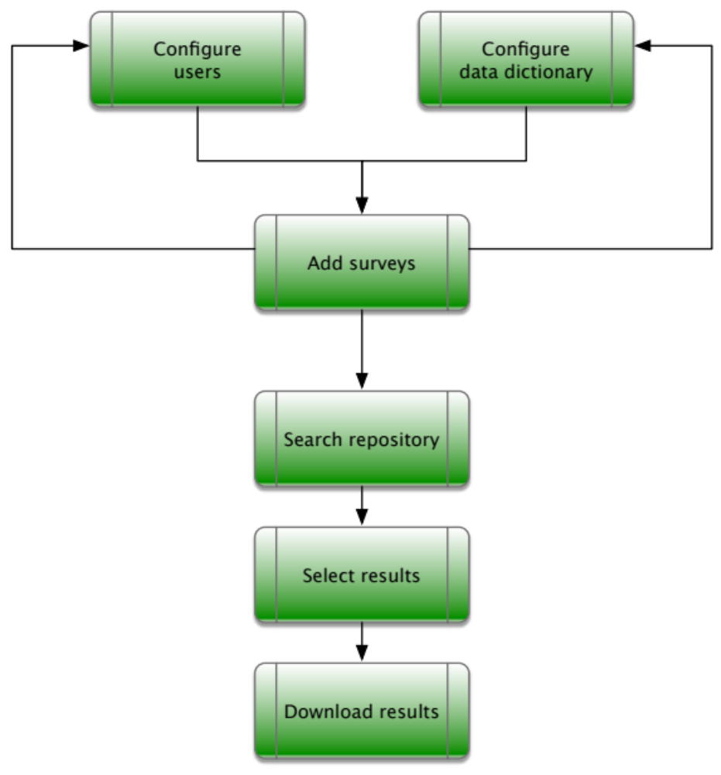
Configure users
The repository should be governed by a credentials system which limits access to users according to their operational profile. Before adding surveys, it is necessary to register the users and assign roles that will determine which operations they are allowed to perform and what elements of the user interface will be enabled or disabled according to their roles.
There are many use cases that should be governed by the credentials system:
- Administration. There are several administration activities: creating users, running batch procedures and administering the system. These functions should be performed by personnel that is dedicated to those tasks.
- Uploading and documenting. Only a dedicated set of users should be able to upload surveys into the system and providing the ability to fill metadata should only be given to users that are qualified to do so.
- Harmonising. Harmonising datasets is a task that requires both a good knowledge of the variables featured in the dataset and a good knowledge of the variables featured by the master data dictionary.
- Data dictionary. The master data dictionary should be curated by a class of users that have the know-how to manage and add new variables to the data dictionary.
- Querying and downloading. Some datasets will be restricted and only available to a set of dedicated users. Downloading can also be restricted to a set of users.
- Public. The repository may be searchable by any user, providing access only to those surveys qualified as public, or the repository could be only accessible following a login. It should be clearly defined what operations a “public”, not registered, user can perform.
Rather than defining a hierarchical set of use cases, it is more flexible to have a hierarchy of users, each of which is assigned a specific set of roles. A user may create several other users and the user creator should have access to all assets created by its “siblings”. Here are the roles that can be assigned to users:
- Authentication. This role provides the ability to create, modify and delete a user. If user A creates user B, user A can change the roles assigned to user B or delete it; if user B also has this role and creates user C, user A and user B will be able to manage user C.
- Batch. The application should provide the ability to perform batch maintenance procedures, only users with this role will be able to see and initiate these tasks.
- Upload. This role will provide users the ability to upload survey files to the repository. Besides sending the files to the system this role should provide the ability to register basic information regarding the survey and its files, this will not include all the survey metadata, but the subset of this information which is necessary to identify the survey, and that can later be completed by users having the Metadata role.
- Metadata. This role allows users to document surveys by filling or modifying all survey metadata fields. These operations will only be allowed for surveys uploaded by them or by users created by them.
- Harmonisation. When a dataset is first uploaded, its original file will be stored into the repository for future download and its contents will be parsed and stored temporarily into a table that will be used during the harmonisation process. Users having this role will be allowed to match dataset variables with the data dictionary variables. This role should also provide the ability to suggest new variables for the data dictionary: it will allow the user to add a new temporary variable to the master data dictionary which can be made permanent by users having the Data dictionary role.
- Data dictionary. Users with this role will be able to curate the data dictionary. This includes modifying and updating the fields comprising the variable’s definition, adding new variables to the data dictionary and approving temporary variables suggested by other users.
- Store data. This role allows users to decide when the harmonisation process is over and the temporary dataset table can be transferred to the database of datasets.
- Query. This role allows users to query the repository, the value of the field determines which datasets the user will have access to (note that the query includes the status of the dataset, this setting will restrict the choice of status). The field can take the following values:
  - Public. This setting will include only datasets whose status is Public.
  - Restricted. This setting includes Public datasets and datasets having the Restricted status. Restricted datasets are limited to users that uploaded the survey and to all users above in the hierarchy.
  - All. This setting allows including any kind of dataset in searches.
- Download. This role allows downloading the results of a query and the files comprising the survey; users who do not have this role can only consult search results on-line.
The process of creating users can be divided into two workflows:
- Registered users. These will be users created by users having the Authenticate role, these will typically include users that will be responsible of maintaining the repository. The creator user will provide the created user’s name, the e-mail that will be used as the user code and the roles assigned to the user; an e-mail will be sent to the created user with a link pointing to a form in which the created user can modify the name, add the password and any other required information.
- Register on-line. A registration form can be provided in the web site, prompting the user for the e-mail, password and other information, such as institution, intended usage of data and acceptance of terms of use. Once submitted, the user will be created with the predefined set of public roles, which will typically include only Query Public and Download.

Configure data dictionary
The master data dictionary provided in the application will include all default variables, if other variables of interest should be added to the dictionary, it is a good idea to add these before adding the surveys, to prevent having to repeat the harmonisation process at a later stage.
Since the data dictionary will provide the ability to have labels and definitions in several languages, it is a good idea to update the dictionary with translated material in this phase, so that, when harmonising and searching, the needed language will be available.

Upload survey
This phase consists in uploading the files comprising the survey. Users featuring the Upload role will be able to register the survey, upload the survey dataset(s), questionnaires and reports.
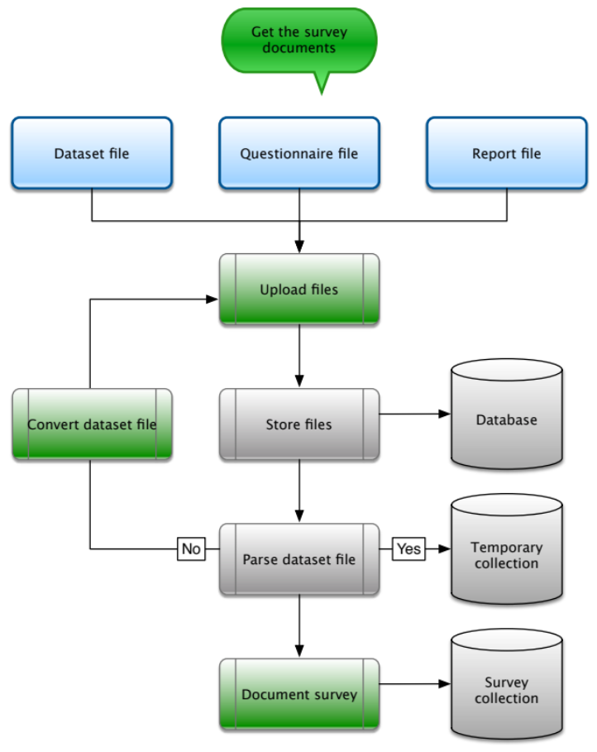
If the user only has the Upload role, he/she will have to provide two necessary elements of information: the survey IDENTIFIER and the DATASET fields. The survey identifier will represent the unique ID of the survey. In the DATASET section the IDENTIFIER and TYPE subfields must be indicated by the user, while the STATUS will be set automatically to In-progress and the USER will be set with the identifier of the user uploading the files.
The original files will be stored in the repository without modification to be downloaded when requested. The dataset files will be processed by the application to store their contents in a temporary table. This step may fail if the dataset is in a format that is not recognised by the system. ENA software files, with the “.as” file extension, Excel files and CSV files should be supported by the system. If the parsing fails, the file should be converted or fed to the ENA software, exported in one of these formats and uploaded again, until the parsing succeeds.
If the user has the Metadata role he/she can compile the fields constituting the survey metadata. If the LOCATIONS field is included in the dataset, all distinct values can be entered in the corresponding survey metadata field, LOCATIONS, by the application, or it might be implicit, if the survey was conducted in a specific location, in which case the user should enter the correct code for the location. This means that the locations controlled vocabulary should already be in place when adding the datasets, or it should be updated as new locations are identified in the datasets; some work by users with the Data dictionary role should be performed beforehand.
The SURVYEAR and SURVMON fields should hold respectively the main year and month in which the survey was conducted.
AGENCY, SUPERVIS and REPCODE can be looked up in the reports of the survey. SAMPMETH, SAMPSIZE and CLUSTNUM, along with the following 11 fields covering data quality could be entered manually by consulting the ENA software data quality report.
Once all files have been uploaded, the datasets parsed and the survey metadata has been compiled, it will be possible to proceed with the next step that involves harmonising the dataset with the data dictionary.

Harmonisation
In this step, the dataset exists in the repository in two forms: as the original file uploaded to the repository and as a temporary table that contains the dataset’s data. This temporary table will be available to the application for display and processing and will be progressively updated to finally contain one header line with the variable names associated to each column and the rest of the rows containing the data.
The goal of harmonisation is to process the temporary table until:
- It has one header row and all the following rows contain data.
- Each field in the header row contains the name of the variable associated to its column.
- All columns that correspond to a variable in the master data dictionary have that variable’s name in the corresponding header’s row field.
- All fields in the header row have unique names; this is necessary to disambiguate variables.
Header and data rows detection
The first operation that must be performed is to identify which is the first row of data and which row contains the variable names; the latter will be called the header row. In order to provide this information to the application, the original dataset table will be displayed to the user, the first 10 or 15 lines are more than sufficient, and the user will have to indicate:
- Which row corresponds to the first data row.
- Which row corresponds to the header row containing the variable names.
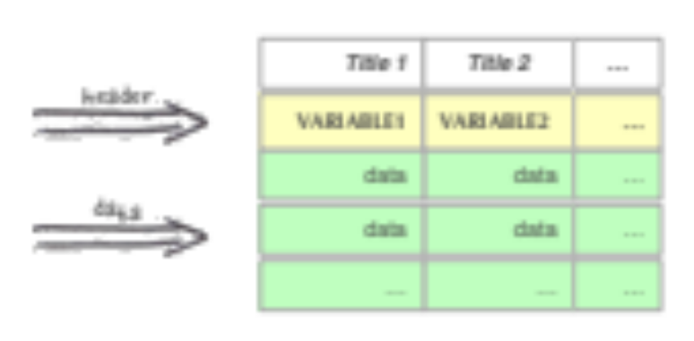
The user will click on a row and press a switch labelled “Header” or “Data” to indicate where to find variable names and where to get the data.
If the dataset is in the ENA software format, or was exported unmodified in another format, it will generally have a single header row that can be used as the list of variable names. If the dataset is not in the standard format it may have different variable names, or several header rows that identify the contents of the column data. In this case, the header row supposed to contain variable names may not contain that information and it will be necessary to correct the fields of the header row to be able to match the dataset variables with the master data dictionary variables.

Master data dictionary matching
This process aims at identifying all variables in the dataset which correspond to variables in the master data dictionary, this is done by setting in the corresponding header row fields the names of the related variable in the master data dictionary.
The application will attempt to perform this match automatically by comparing the values of the header row with the variable names in the data dictionary, if there is a match, the corresponding column will be highlighted to signal that the column may correspond to the matched variable.
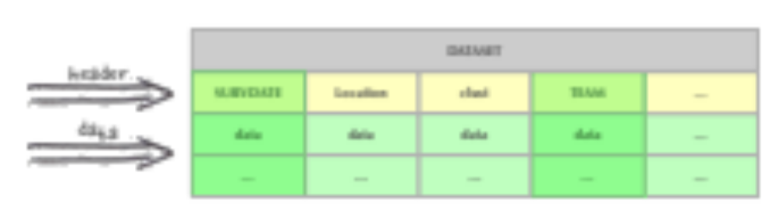
For standard SMART surveys, this step will be sufficient to complete the harmonisation. If the dataset is not in a standard format and the variable names do not correspond to the variable names in the master data dictionary, it will be necessary for the user to indicate for each column to which variable it corresponds.
This can be done in two ways: by entering on-line the correct variable name in the corresponding field of the header row, or by clicking on the relevant column and selecting the correct variable from a window or pane displaying the master data dictionary.
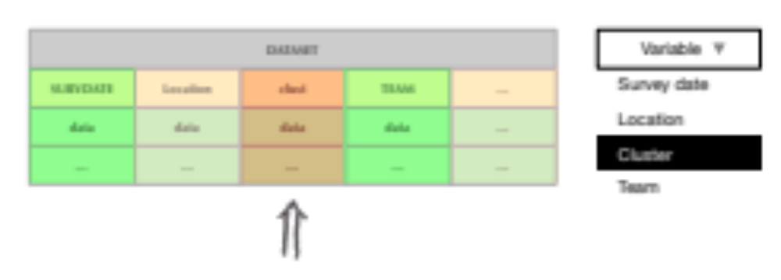
In the first case, as soon as the variable name in the header row has been updated, the application will attempt an automatic match. In the second case, the corresponding field in the header row will be updated to contain the selected variable name.
As the header row is being updated there might be cases in which this row will have duplicate values: this must be prevented since each column of data, belonging to a specific dataset, must have a unique variable name. This is also relevant for columns that do not correspond to variables in the master data dictionary, so, in that case, it is the responsibility of the user to choose the right variable name. Variable names must be alphanumeric, allow a limited set of special characters, such as underscore (_) or dash (-) and not contain more than 32 characters. This is to allow most statistical software applications to be able to use these values as legal variable names.
New variable names can be added to the data dictionary at all moments, this can be done by users with the Data dictionary role and their contributions will be immediately available in the harmonization phase, but it can also be useful to allow users uploading datasets to suggest new variables for inclusion in the data dictionary. This could be done in this phase by displaying a form that would allow the uploader to create the definition of a new variable which will be stored with a special value in the Status field of the variable metadata. At a later stage these suggestions could be reviewed by a user with the Data dictionary role and made permanent by changing their status to permanent.
If a new variable has been added while harmonising a specific dataset, its data in that dataset will be associated to the new variable in the master data dictionary, but the same variable may occur in other datasets: this means that the other datasets will have to go through the data dictionary matching again. Since it is guaranteed that variable names within a single dataset are unique, when the dataset is being matched again, all variables prior to the new variable will be automatically recognised by the application and the user will only have to match the new variable.
During the whole matching process a pane in the main window will contain the master data dictionary contents, so variable names can be entered by keyboard or the desired variable selected from the displayed dictionary. The data dictionary can also be presented as an ontology, grouping different types of variables under specific categories to make browsing the dictionary easier in the event it contains a lot of entries. Also, whenever the user clicks on a matched column, or whenever a typed variable name matches one in the data dictionary, all the information about the variable will be displayed in the window, this will provide enough information to assess if the data corresponding to the variable indeed belongs to that variable.

Data check
As columns of data are matched with variables in the data dictionary, the contents of data will be analysed and the results will be displayed, this will provide the necessary information to the user for determining whether the data indeed corresponds to the chosen variable, or if the data unit needs to be converted.
Each data type will be treated in a specific way.
Dates. Dates can be expressed in many different data formats and values, by default we assume all dates are character fields following the YYYY-MM-DD format in which Y represents the year, M the month and D the day. When parsing data from Excel files, for instance, dates will be expressed in the format corresponding to the locale of the computer that generated the file, this may be compatible, or it may be DD-MM-YYYY or MM-DD-YYYY. Sometimes, a format mismatch can be easily spotted by looking at the data, but other times a user would need to scroll records until a value can show this difference. The window could list the number of incorrect dates found in the data and some examples of the incorrect values, this would allow users to quickly determine the source format of the dates and click a button next to the assumed format and have the application automatically convert all dates to the standard format. Sometimes a date may be expressed as an integer value, which represents the internal format used by computers to store dates, in this case the value will be converted to the standard format.
Measurements. These types of values will be numeric. Variables expecting centimetres, but expressed in millimetres could be easily spotted by the user by looking at the first values in the displayed table, but could also be flagged if the variable definition contains legal minimum and maximum bounds. Again, as for dates, the number of incorrect values and a short list of examples will be displayed below the column corresponding to the variable. The user could select the unit expressed in the dataset and have the application perform the conversion automatically.
Another error that may occur is type mismatch. Measurements are supposed to be numeric, if a character entry is encountered this might be an error, or it might indicate that the variable is a controlled vocabulary featuring a list of ranges, this if all values are not numeric. In the latter case a new variable should be created, since a raw measurement cannot be compared with a categorical value.
Controlled vocabularies. A variable that uses a controlled vocabulary can only take its values from a predefined list of choices. These choices are composed by a key/label pair in which the key will be used as the variable’s value and the label will be stored in the master data dictionary for display when showing data. ISO countries are a good example: “FRA” is the key corresponding to “France”, which is the label. For non-standard variables and location codes it will often happen that the dataset may contain a different set of keys: when a column is associated to an enumerated variable, the application will display the distinct set of keys found in the dataset and the key/label pairs contained in the master data dictionary. Those entries which do not match the standard will be highlighted and the user will have the following options:
- Incorrect key. If the key does correspond to an entry in the controlled vocabulary, the user can select the wrong key, select the correct key and let the application perform the conversion. For instance, a yes/no vocabulary may be defined as “y: Yes and n: No” in the data dictionary, but as “1: Yes and 0: No” in the dataset, the user would, for instance, select the highlighted “1”, the “y” in the dictionary vocabulary and press a button to prompt the application to convert all “1” entries to “y”.
- Incorrect matching. There may be cases in which the vocabulary in the dataset is encoded differently than in the data dictionary and an element of the vocabulary of the dataset has been matched with the incorrect element of the vocabulary in the data dictionary. In this case, the user can select the incorrectly matched element of the dataset and the correct choice in the data dictionary and let the application perform the conversion.
- New vocabulary element. Sometimes the dataset may feature vocabulary elements that are not contained in the data dictionary controlled vocabulary. This will often happen for location codes. A new location has been surveyed which was not previously included in the data dictionary, or an old obsolete location is found in a dataset. In these cases, it might be necessary to update the controlled vocabulary in the master data dictionary by adding a new key and its corresponding label.
All conversions performed in this phase and any field in the dataset still having an incorrect value will be logged in the corresponding survey collection. The logged information, along with the data quality information from the ENA software stored as survey metadata will be available as query attributes to select surveys based on their data quality.
Once the variable matching and the data check have been completed, a user with the Store data role can tell the application that the dataset is ready for use. The application will transfer the contents of the processed dataset to the final data collection, delete the temporary tables used for processing and set the status of the dataset to Public or Restricted, depending on the intended access rights. At this point the dataset is available for search.

Search
Once the repository is filled with surveys and data, users will be able to search datasets by providing a query whose attributes will be formed by survey metadata and data field values. A query clause will be composed of three elements: the variable, a compare function and a search value. Users will choose variables from the displayed data dictionary, including variables related to surveys and variables related to survey datasets. When a user selects a variable, the list of compare options will be presented which correspond to the variable’s data type. String values can be compared by matching the whole value, or matching start, end or contents of the variable. Numeric values can fall within a range, or match the provided value. A set of elements from a controlled vocabulary can be selected to match enumerated variables. The presence or absence of a variable can also be used in the search clause. Finally, the user can indicate which value should be used for the comparison. Several of these triplets can be added to the query until all desired conditions have been indicated. Variables related to surveys will limit the number of returned surveys and variables related to the contents of survey datasets will limit the number of data records returned.
The results of the search will take two distinct forms: surveys and data selections. Selected surveys will be presented in a table containing the survey’s metadata, along with links to the documents that comprise the surveys. Data selections will be a single table containing all the resulting data from the datasets of the selected surveys filtered by the query attributes relating to variables contained in the datasets.
Summarisation and analysis functions could be added to the application and applied to the resulting data selections, this could be used to generate summary data or populate an interactive data panel and display graphic results
If the user has the Download role, it will be possible to download the results of the query. Surveys can be downloaded as a table containing the survey metadata, or as a compressed archive containing the documents comprising each survey. Data selections can be downloaded as a single dataset in several file formats described below. Before downloading, the user will have the possibility to select which variables to include or exclude: this is especially relevant when downloading data selections, to limit the number of variables in the table and to add survey specific fields to the resulting dataset.
The application should support the following file formats:
- Zip archive. This type of file will be used for survey selections, they will contain a table with the survey metadata in Excel format with one workbook containing the metadata dictionary and another containing the survey metadata fields. Following, there will be a series of directories, one for each survey, containing the files that comprise the survey.
- Excel. This type of file can be used to export both survey metadata or data selections. The file will contain two workbooks, one with the data dictionary and another with the data.
- Stata. Stata includes the data dictionary along with the data, for this reason this format may be ideal when exporting data for further analysis. The preferred method would be to create an archive containing a CSV file with the data and a Stata do-file containing the data dictionary and the commands to import the CSV file. This method is preferable to generating a Stata native file, because their file format changes often and keeping up with the versions would prove unsustainable in the long run.
- R. The same process as for Stata could be done to generate files that can be imported into R.

Software Structure
The software application could be deployed as a web application connected to a database. It will be accessible to users as a web site, requiring only a web browser to interact with the application.
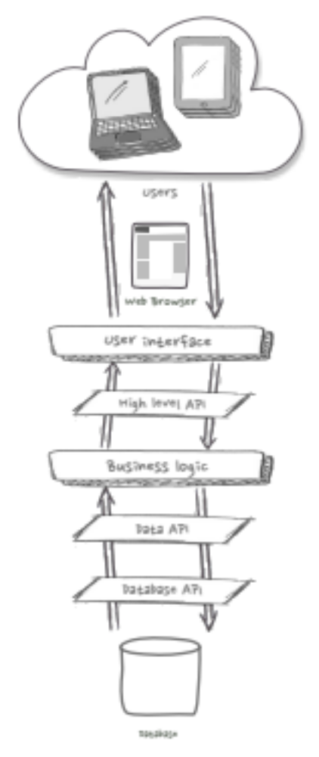
The system structure should be modular, with separate layers, independent from each other, connected by a series of Application Programming Interfaces (API).
The first layer represents all the web pages that comprise the application, we call it the user interface. Users will fill forms to load information, perform searches, and the system will respond with web pages featuring tables, graphs and lists of items that can be downloaded.
This user interface will communicate with the other application layers via an API which represents a way to formulate high level requests. The set of operations available through this protocol should cover all the needs, such as create a new user, check if the current user is entitled to perform a specific operation, send a query to the system, download a selection of surveys or data, etc. What should characterise this API is that it should govern all interactions between users and the application, both covering what messages can be sent and what information will be returned by the application.
These requests will generally be divided into a series of smaller and simpler operations, including validation and returning eventual error messages. This is where the business logic layer comes into play. For instance, adding a new user can be broken down into a series of steps: check whether the current user is an administrator, validate the data comprising the user record, check whether a user already exists with the same name or code, create the user data record in the database, initialise eventual other related records, return a confirmation message. All these atomic operations will be triggered by the business logic layer as the response to a high-level request.
The operations triggered by the business logic layer involve storing and retrieving information from the database, this should be done through a low-level protocol that covers all data input-output operations. The data API will provide a protocol for storing and retrieving objects, such as storing a user, making a query or retrieving a specific item. What characterises this protocol is that it should be database-agnostic, in other words, it should only concentrate on the intended operation without incorporating the specifics needed to communicate with the database engine in use.
The requests generated by the data API will be fed to the database API which will translate the high-level request into operations understood by the specific database engine used in the application.
There are many advantages in splitting the system in layers and protocols. First, once the protocols or APIs have been defined, work can begin on all the layers, since these will only communicate through the defined protocols and what is expected as input and as output is already established. Also, the order in which these layers are developed does not depend on creating a working prototype, since results can be matched with templates providing the expected protocol messages. Finally, this allows the system to be sustainable, since changes to a single layer should not affect the other layers. Changing the database would simply mean changing the database API, while the rest of the system would not need to be revised.
The other advantage of this structure is that the system could interact with other types of users. The high-level API could, for instance, be used to receive survey data collected using a tablet, allowing the system to be updated in an automatic way.

Implementation
The application will be comprised by three main components: the web server which handles the user interface web pages, the application server that responds to the high-level API and implements the business logic, and the data server that responds to the data API and manages the database requests. These components will communicate with each other through web services using the JSON protocol, which is a common standard.
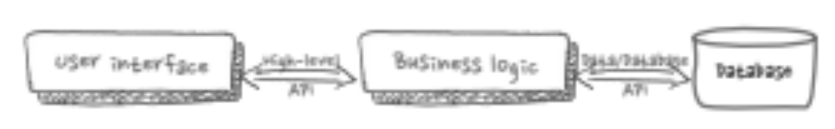
The user interface web pages can be implemented using a combination of standard HTML and scripts written in languages such as PHP, Python or JavaScript. There may also be different versions of this layer to handle browsers running on slow machines or that do not support certain features of JavaScript.
The business logic layer could be implemented in those same scripting languages to follow consistent standards, or in another language to take advantage of statistical programming libraries when generating analysis and statistics.
The database should be fast and flexible enough to accommodate dynamic and growing schemas of the data dictionary and metadata. We suggest using a NoSQL type of database, since it simplifies the task of adding new fields, is not bound to a schema and it is able to handle types of structures, such as graphs, that are not supported natively by the traditional relational databases.
Being a layered system its packaging can be very flexible, varying from a single PC based application to three components residing on three separate servers.

Deployment
Since the application is divided into components and it is web based, there are many ways in which it can be deployed. As the number of surveys grows it is possible to scale the system to handle the increased data load. The real issue is how to balance flexibility and privacy.
The ideal configuration in terms of flexibility and sustainability would be to make it a cloud application. This means that it would be deployed as a centralised server in the cloud. Although such a configuration can be made private and safe, just as all financial transactions currently performed using internet, it might not be perceived as such by users who want to have full control on all the elements of the system, so the application could be deployed in several possible configurations.
Centralised cloud repository.
This configuration would make the application available to all from a central unique source located in the cloud. All users would access the application from a single web portal and store their data into a single database, in which privacy and data separation is implemented at a central level.
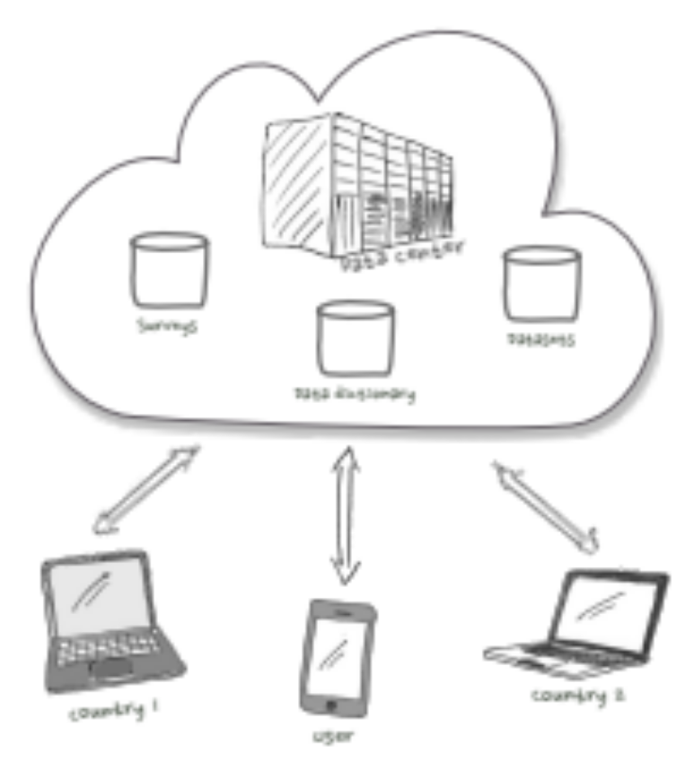
The repository would hold all the data from all users, all surveys are stored in the database of surveys and all datasets are stored in the database of datasets. The data dictionary is shared by all users and any change is immediately available to everyone. This last feature is key to ensuring consistency of data at a central level, and the master data dictionary will make use of the pooled work of all users of the repository. This is especially useful when adding variables and when translating variable definitions: new users can take advantage of this and add to the work of others.
The main advantage of this configuration is that there is a single instance of the application, which means that any update will be available to everyone and there can be economies of scale in terms of infrastructure.
Privacy concerns can be handled by restricting access to data based on user groups: for instance, only users from a specific country will be able to add surveys conducted in that country, restricted surveys will only be visible by their user’s hierarchy, while public surveys will be accessible by all users. This makes access to data restricted only to those entitled, without having to physically separate and multiply installations.
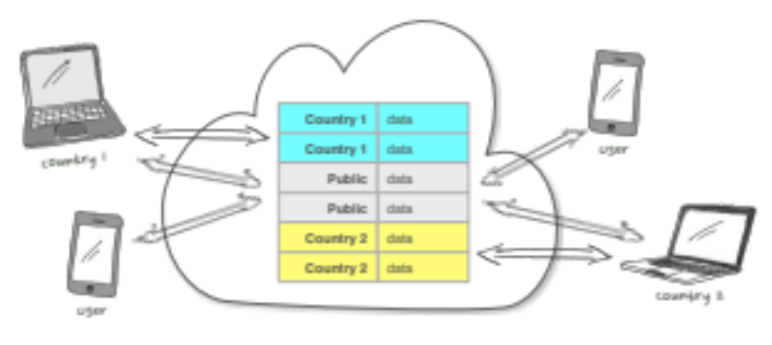
As the size of data increases, it is possible to scale the system so that the response of databases and the connection speed will not degrade. This process is called sharding, which means that there will be more than one instance of the repository and each instance will contain data specific to a group of users.
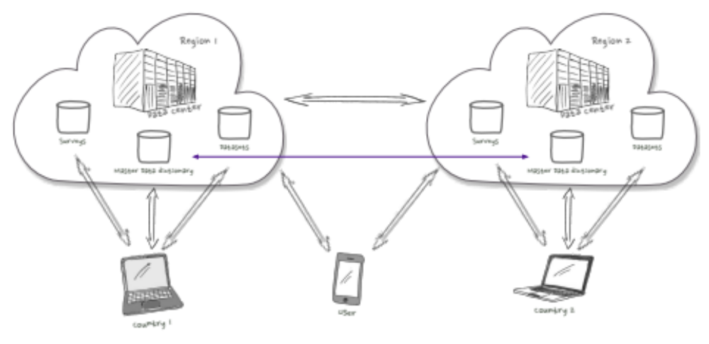
For example, instance 1 will contain surveys and datasets from Asian countries, both restricted and public. The same will be true for instance 2 which will contain data from African countries. The advantage of splitting in two the whole data is that each instance will contain a portion of all the data, making queries faster and more efficient; and, if located in the same region as the countries from which data is hosted, will make access times faster. While distributed, the database will still provide access to all data, meaning that users in one region can still query data from another region through their specific access point, this is a feature that is transparently provided by modern databases.
When country 1 connects to the repository in region 1 their access times will be faster and since most queries and data uploads will mostly concern only their data, they will be mostly using the database of their region. Since the database is sharded, it is also possible to access data from other regions, so a user in region 1 will have access to all public data of all regions. With sharding the repository presents itself as if it was a single central portal, except that it is accessible through several nodes and the data is distributed among these nodes.
Separated repositories
If privacy is the main concern and countries are not comfortable with having their data stored out of their country, it is possible to have a configuration in which each country hosts its own repository in a physical server located in the country itself.
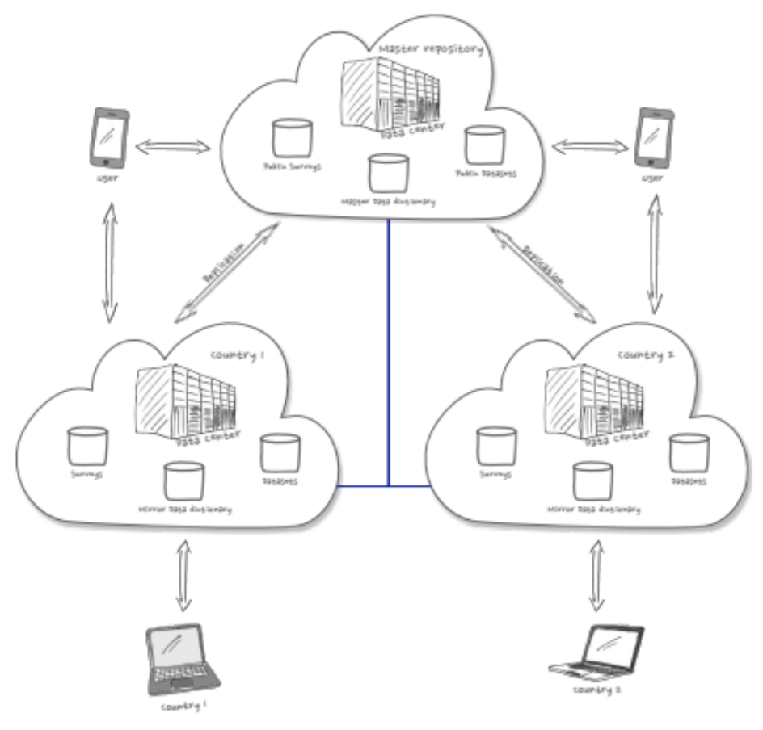
In this configuration, each country hosts a complete repository installation, they only manage data from their country and can provide access to their public data if they want to. There is a master repository which stores public data from all countries, the decision to share or not this data is entirely the responsibility of the countries. The main function of this master repository is to centralise the data dictionary. Here all changes to any of the country local data dictionaries is synchronised with the master data dictionary in the master repository, so all countries have access to the same set of variable definitions. This is the only element that is shared among different countries.
Surveys and datasets can be pushed from the country to the master repository through replication, which means that there will be no need to harmonise data since the data dictionary is shared and the harmonisation was already done at the country level, the process can be made simpler and virtually automatic. This will provide the choice to countries to select what public information they want to publish on their own and which information they want to make available through the master repository; in theory, only the data dictionary could be managed by the master repository.

